

**Adult Weight**

**The Adult Weight Management Service**

Self-Referral

Information ****ation

**What To Expect**

First you will attend a **one-to-one assessment appointment**.



Next you will start our **Core Skills programme**. This is designed to help you get started with losing weight.



When you have completed the **Core Skills programme** you will have an appointment with a member of our team to discuss your progress and explore options of further support from our service if required.

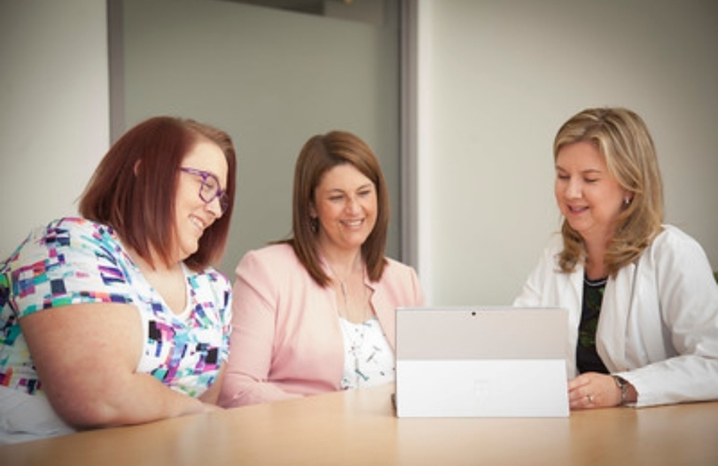

**Frequently Asked Questions**

**Will I be put on a specific diet plan such as Keto or a diet for my blood type?**No. There is no scientific evidence that shows one particular diet can help you lose weight and keep it off in the long-term. The Weight Management Team will support you with making lifelong changes to lose weight.

**Do you test for hidden medical causes of weight gain?**No. Your GP can carry out relevant tests to check for any health conditions that may be related to your weight. We are also unable to offer genetic testing.

**Can I be referred for Bariatric (weight loss) surgery?**Yes. If you feel you could benefit from surgery, please tell us at your first appointment. Selection for surgery depends on a number of factors and the final decision rests with the Welsh Institute of Metabolic and Obesity Surgery (WIMOS).

**Do you prescribe medication to help people lose weight?**  
Yes. People who meet specific criteria can be prescribed weight loss medication. If you feel you could benefit from this please tell us at your first appointment. If you have already tried to lose weight by making diet and lifstyle changes your GP may prescribe a medication called Orlistat.

Image by Vecteezy.com

**

*Images by Obesity Canada*

**The First Steps**

If now feels like the right time to begin making life-long changes to lose weight, you can refer yourself in two ways:

You can visit our webpage at: **<https://abuhb.nhs.wales/hospitals/a-z-hospital-services/weight-management-service>** and click on the link to watch our short video and fill in the online referral form.

**OR**

Phone us on **0300 3034906** (Tuesday and Friday mornings only). Calls will take around 15 - 20 minutes.

Please remember to have your height, a recent weight and a list of your current medication ready. We cannot complete your referral without this information.

**Are you ready?**

We see losing weight as a lifestyle choice as opposed to a quick fix. However, we appreciate that making lifestyle changes can be challenging, and sometimes life gets in the way. It’s important to enter this service at a time where you are able to make changes that you are able to maintain over the long term.

Consider the statements below to help you assess whether now is the right time to commit to managing your weight:

***‘’I feel the benefits of losing weight outweigh any negatives’’***

***‘’Losing weight is at the top of my priority list right now’’***

***‘’I don’t have any big life changes happening at the moment’’***

***‘’I have time in my week to attend regular appointments’’***

If all the statements above apply to you, now may be a good time to take the first step.

**What We Do**

The Adult Weight Management Service is a friendly, multi-professional team that are here to help answer all of your questions. We understand that there is no one-size fits all approach to losing weight, and can guide you to make changes at a speed that you feel comfortable with.

We deliver a variety of one-to-one and group-based programmes to support you with making positive lifestyle changes, whatever your circumstances may be. We aim to provide tailored support to help you overcome any obstacles in your weight loss journey.